# Lab-9 WAP to study Using compound object and lists in prolog.

Procedure:-

1. Write a program to maintain inventory items using a compound object.

The format of compound object should be (item type, item (no, description, qty, cost))

Item-type can be fg-finish good, sf-semi finish good, rm-raw material, Write appropriate predicates to

1. Accept from user the details of atleast 10 such objects
2. Display the details of objects entered by user.

**Code:**

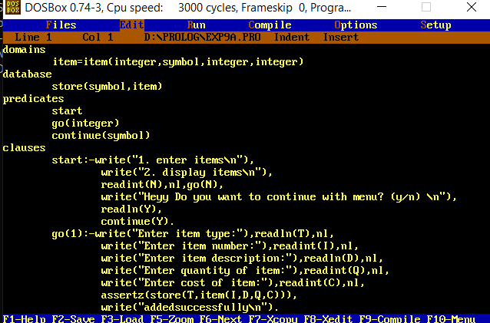

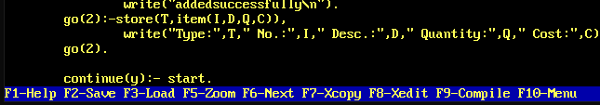

**domains**

**item=item(integer,symbol,integer,integer)**

**database**

**store(symbol,item)**

**predicates**

**start**

**go(integer)**

**continue(symbol)**

**clauses**

**start:-write("1. enter items\n"),**

**write("2. display items\n"),**

**readint(N),nl,go(N),**

**write("Heyy Do you want to continue with menu? (y/n) \n"),**

**readln(Y),**

**continue(Y).**

**go(1):-write("Enter item type:"),readln(T),nl,**

**write("Enter item number:"),readint(I),nl,**

**write("Enter item description:"),readln(D),nl,**

**write("Enter quantity of item:"),readint(Q),nl,**

**write("Enter cost of item:"),readint(C),nl,**

**assertz(store(T,item(I,D,Q,C))),**

**write("addedsuccessfully\n").**

**go(2):-store(T,item(I,D,Q,C)),**

**write("Type:",T," No.:",I," Desc.:",D," Quantity:",Q," Cost:",C),nl,fail.**

**go(2).**

**continue(y):- start.**

**Output:**

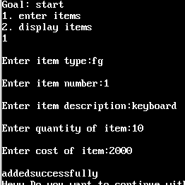

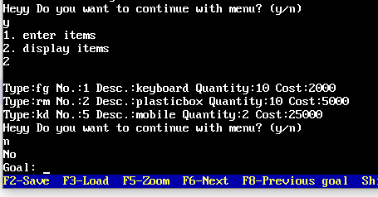

Procedure:-

1. Find and display odd and even numbers from a given input list of integers Example:- Output:- Enter list of 10 integer numbers 1 2 3 4 5 6 7 8 9 10

Even numbers -> 2,4,6,8,10

Odd numbers-> 1,3,5,7,9

**Code:**

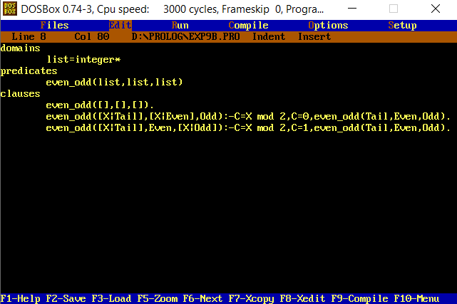

**domains**

**list=integer\***

**predicates**

**even_odd(list,list,list)**

**clauses**

**even_odd([],[],[]).**

**even_odd([X|Tail],[X|Even],Odd):-C=Xmod2,C=0,even_odd(Tail,Even,Odd).**

**even_odd([X|Tail],Even,[X|Odd]):-C=Xmod2,C=1,even_odd(Tail,Even,Odd).**

**Output:**

